Student’s name | …………………………………………………….…… | Grade | 3
Subject | Computer | Week No. | 6
Lesson Title |  | Unit
Midterm Exam Worksheet

Question A: Match the following according to their usage.

 | FOR BANKING
 | FOR ENTERTAIMENT
 | FOR EDUCATION
 | FOR ART
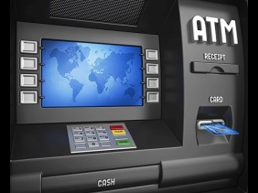 | FOR COMMUNICATION

Question B: Match the following with the correct software icons.

-  | Sketchbook
-  | Paint
-  | Calendar
-  | Gallery
-  | Notebook

Question C: Match the following according to their usage.

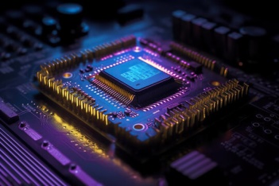 | VIDEO CARD
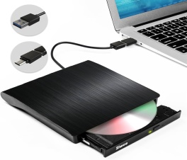 | LAPTOP BATTERY
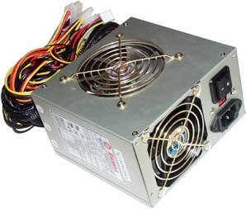 | CENTRAL PROCESSING UNIT
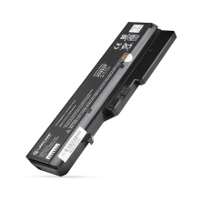 | EXTERNAL DISC
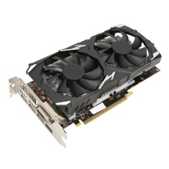 | POWER SUPPLY

Question B: Fill in the blanks.
- ___________ is used to provide power to a computer.
- ___________ connects all the parts of a computer together.
Question C: State whether the statements are True/False.
- A disk drive is also called DVD drive.
_____________

ANSWER KEY
Question A: Match the following according to their usage.

 | FOR BANKING
 | FOR ENTERTAIMENT
 | FOR EDUCATION
 | FOR ART
 | FOR COMMUNICATION

Question B: Match the following with the correct software icons.

-  | Sketchbook
-  | Paint
-  | Calendar
-  | Gallery
-  | Notebook

Question C: Match the following according to their usage.

 | VIDEO CARD
 | LAPTOP BATTERY
 | CENTRAL PROCESSING UNIT
 | EXTERNAL DISC
 | POWER SUPPLY

Question B: Fill in the blanks.
- Power Supply is used to provide power to a computer.
- CPU connects all the parts of a computer together.
Question C: State whether the statements are True/False.
- A disk drive is also called DVD drive.
True

